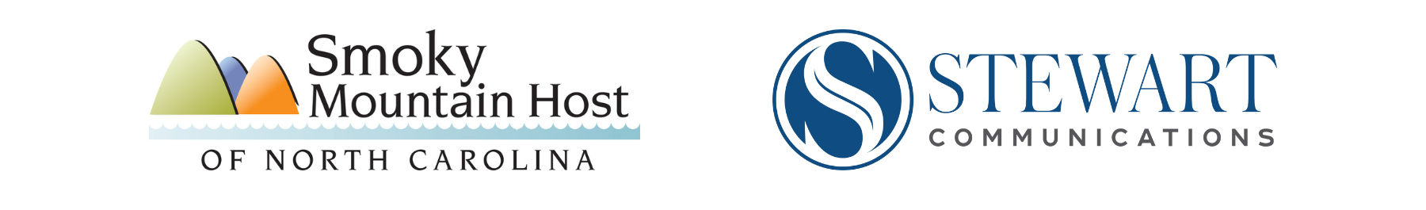

Post-Helene Tourism Recovery
Talking Points

Avoiding The Devastation after the Storm
- Our residents and small, family-owned businesses of the western-most counties of the NC Smokies Region are concerned about facing an economic crisis post Hurricane Helene.

- After the storm hit, and the devastation in and around the Asheville region made national news, combined with our governor’s comments that WNC is closed, the likelihood increased that our relatively undamaged counties would face an economic storm after the hurricane.

Why We Need Visitors
- October should be a busy tourist season for [business name/location name], instead our businesses are experiencing mass cancellations, which means incredible losses of revenue. A normally active October leaf season carries our local family, small-business owners through the economically slower cold weather months. We are concerned many small, family businesses will not survive the winter.

- Therefore, we are asking vacationers to reconsider their cancellations, and for others to make new plans to head our way. A successful invitation to visitors will help ensure that the devastation of Helene doesn’t expand in our communities.

- Bottomline, the NC Smoky Mountain Region counties are open for business.

What We Offer
- Of course, we first ask that visitors be thoughtful when they travel this way. We ask that all travelers consult driveNC.gov for full details on the road conditions.

- That said, the vast majority of major and smaller roads are open. There are some smaller roads with some lingering damage. And two major roads that are closed - the Blue Ridge Parkway is closed throughout NC, and a 20-mile section of I-40 at the Tenn./NC line. Otherwise, the state website shows virtually clear paths for all, no matter where they travel from.

- In terms of lodging, while our national chain and local large hotels may be booked with 1st responders and restoration workers, our Bed and Breakfasts and vacation homes are available. We ask that visitors call ahead to double check their reservations to ensure no surprises are waiting for them at check-in.

- For those looking to experience small mountain town life, our stores and restaurants are open, and our Halloween/Fall events are taking place as planned.

- For those looking for more than a majestic scene from their rental home’s deck or a B&B’s firepit, our national forests from the Pisgah to the Nantahala are open for hiking, biking, bird watching, ziplining and viewing incredible waterfalls. Or, simply find a scenic pull off, and relax and watch the colors of the changing leaves sparkle all the views around.

- In addition, our rivers, streams and lakes are open for fishing or boating. We want visitors to know they can enjoy the NC Smokies Region blueways on their own, or hire our many professional guides to show them the way.

An Important Reminder
- At the end of the day, there are six counties and Qualla Boundary (Cherokee Reservation) that are open for business. And, we need tourists to visit our communities. Without them, during this normally busy tourist season, we could lose many family-owned small businesses. Our communities depend on visitors, and we welcome you all.

Travel Information Resources

https://www.visitnc.com/
https://www.visitsmokies.org/
https://drivenc.gov/

# # #

