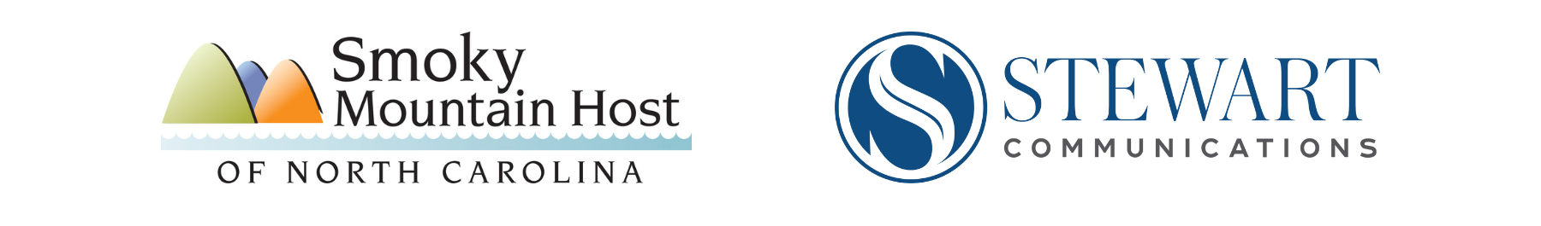

Post-Helene Tourism Recovery
Social Media Toolkit

Purpose
The #WNCSmokies campaign aims to address the ongoing economic crisis affecting our region in the wake of Hurricane Helene. Smoky Mountain Host, in collaboration with Stewart Communications, has created this toolkit in order to equip you with the tools and strategies that can help all of us communicate effectively with One Voice during this sensitive time.
This communication strategy aims to spread the message that our towns and counties are open and welcoming visitors during our Fall leaf season, even as we support restoration efforts. We know that we will be most effective in combating our potential economic crisis if we all communicate the same clear message with One Voice before a crisis deepens, and as a result, we will rise to this challenge and succeed together.

Examples of current WNC Travel content for reference:
https://www.visitnc.com/
https://www.visitsmokies.org/

Social Media Strategy
You should always approach social media with a well-defined strategy. This helps keep your messaging consistent and promotes well-rounded content. For the #WNCSmokies campaign, we recommend the following strategy:

- Post 3-5 times per week on each social channel (Facebook & Instagram) with one of the following types of content:
  - Original Content (something you photographed, filmed, created, etc.)
  - #WNCSmokies campaign content from this Toolkit
  - Curated Content (relevant posts or links from other reputable sources)
- Try to post on consistent days and times; use the Scheduling feature to help stay on track
- Always try to include a visual with your posts (plain text posts don’t catch eyes)
- Alternate various content topic categories to keep your audience engaged and avoid unproductive repetition. We recommend the following topic categories:
  - #WNCSmokies campaign messaging (see Sample Posts section)
  - Promotional (sales, specials, events, related local/regional news)
  - Customer Nurturing (travel information, customer/stakeholder success stories)
  - Engagement (pose light-hearted questions and set up polls to engage your audience)
  - Any other positive content relating to your Business/Town
- DO NOT post the following
  - Photos or videos of damage/destruction from Hurricane Helene (this only perpetuates the negative narrative)
  - Negative comments about other businesses, government officials, customers, etc. (there is a time and place for this, but it’s never on your business channels)

Audience Engagement & Communication
You will very likely receive Reactions and Comments on your social media posts. We recommend the following rules of communication:
- Positive Comments: Feel free to respond to as many positive comments as you can to increase audience engagement
- Negative Comments: Most social media users who post negative or combative comments are just spoiling for a fight and not seeking productive communication. Do not engage publicly (on your social media channels) with users who leave negative comments. We recommend one of the following actions:
  - Ignore the negative comment
  - Delete the negative comment
  - Block the user if they continue to post negative comments on your page
  - If you feel you absolutely must respond to a negative comment, the most you should do is copy-paste the relevant text from your original post as a reply

*Delete any posts/comments on your page from the past month that do not align with the strategy/guidelines laid out in the above sections. Even old content can fuel negative narratives.

Sample Posts
These sample posts serve as campaign assets and examples. You may:
- Use the graphics and post copy exactly as they are
- Add your logo to the graphics
- Add your own additional text to the post copy samples
- Mix & match the graphics and post copy samples
- Use these as inspiration to create your own content

*Most important is maintaining the message that we are open and ready for visitors, and reminding visitors to be thoughtful when traveling.

Message #1 - Travel Informed, [Adventure/Get Hooked/Soar/Savor/Indulge/Play] Here

 | The Great Smoky Mountains adventure is ready and waiting for you this Fall.  While some of our region took a heart-breaking hit from Hurricane Helene, many in our mountain region are recovering and ready for you to join us. Consider this an open invitation from [Business/town] to come and enjoy the amazing Fall leaf season in the Smoky Mountains.  #WNCsmokies #VisitNC #visitnorthcarolina  #northcarolinaoutdoors  #828isgreat #VisitSmokies
 | It’s the most mountain magical time of year, and [Business/town] is ready to welcome you! Our roads and amenities are all open, our weather is perfect for outdoor fun, and getting here is easy when you check with DriveNC.gov for road conditions in surrounding areas.  #WNCsmokies #VisitNC  #visitnorthcarolina #northcarolinaoutdoors #828isgreat #VisitSmokies
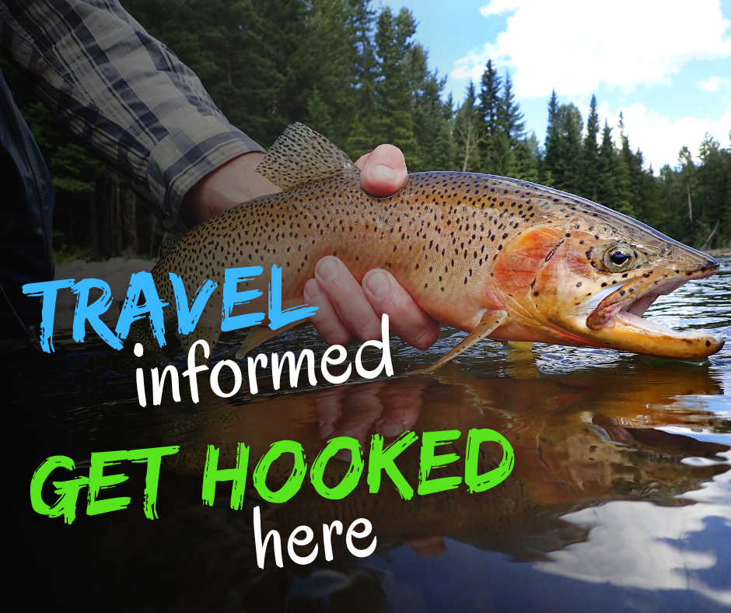 | Come get hooked on your next Great Smoky Mountains adventure this Fall!  While some of our region took a heart-breaking hit from Hurricane Helene, many in our mountain region are recovering and ready for you to join us. Consider this an open invitation from [Business/town] to come and enjoy the amazing Fall leaf season in the Smoky Mountains.  #WNCsmokies #VisitNC #visitnorthcarolina #northcarolinaoutdoors #828isgreat #VisitSmokies
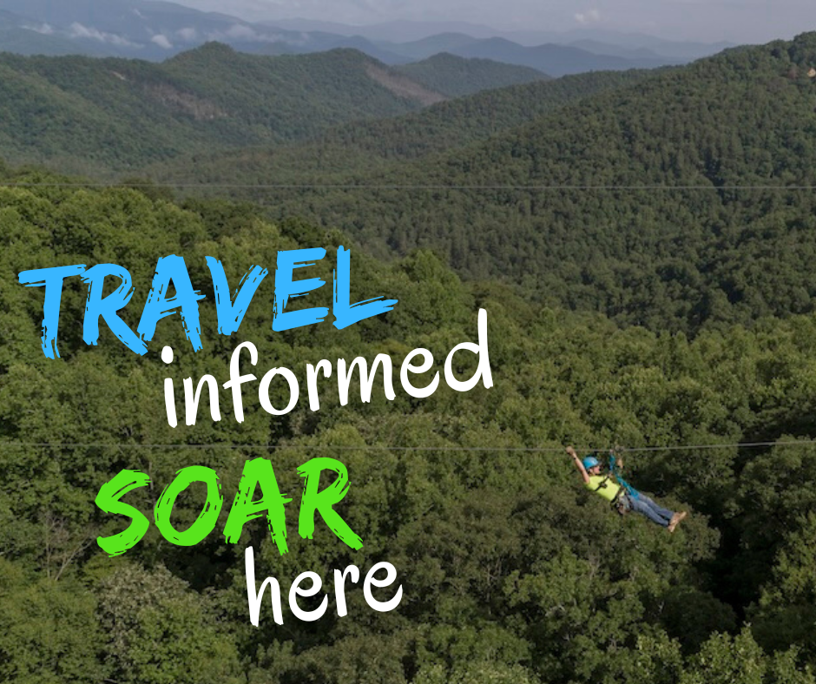 | Come soar through the Great Smoky Mountains this Fall!  While some of our region took a heart-breaking hit from Hurricane Helene, many in our mountain region are recovering and ready for you to join us. Consider this an open invitation from [Business/town] to come and enjoy the amazing Fall leaf season in the Smoky Mountains.  #WNCsmokies #VisitNC #visitnorthcarolina #northcarolinaoutdoors #828isgreat #VisitSmokies
 | It’s the perfect time to savor the delights of Fall in the Smokies! The weather is mild, the leaves are changing, and [Business/town] is ready to welcome you.  Remember that some surrounding communities are still recovering from Hurricane Helene, so please travel thoughtfully and check with DriveNC.gov for road conditions when passing through impacted areas.  #WNCsmokies #VisitNC #visitnorthcarolina #northcarolinaoutdoors #828isgreat #VisitSmokies
 | It’s the perfect time to indulge in the delights of Fall in the Smokies! The weather is mild, the leaves are changing, and [Business/town] is ready to welcome you.  Remember that some surrounding communities are still recovering from Hurricane Helene, so please travel thoughtfully and check with DriveNC.gov for road conditions when passing through impacted areas.  #WNCsmokies #VisitNC #visitnorthcarolina #northcarolinaoutdoors #828isgreat #VisitSmokies
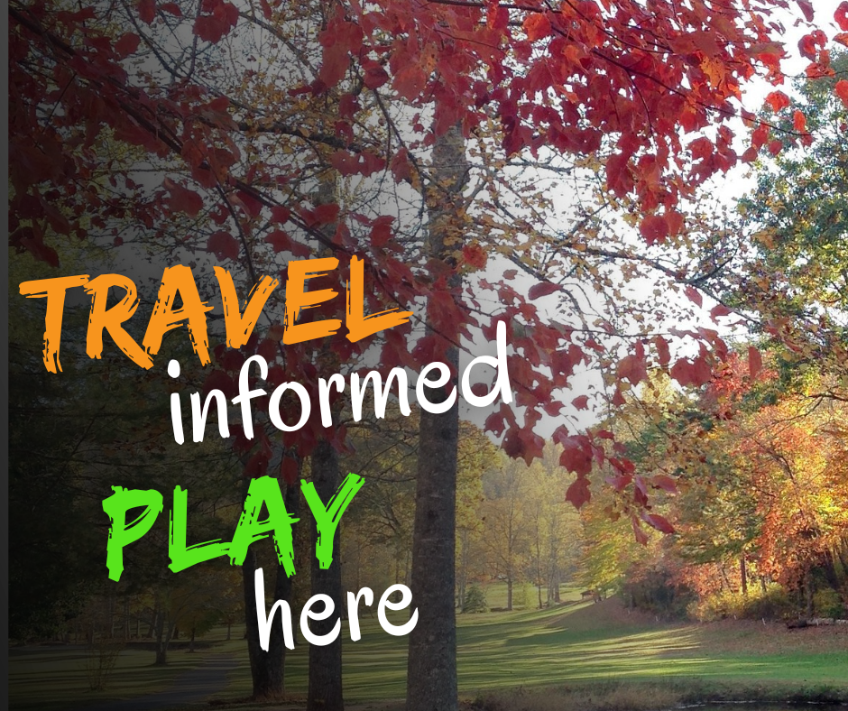 | There’s nothing like playing a round of golf in the midst of Fall leaf season in the Smokies!  While some of our region took a heart-breaking hit from Hurricane Helene, many in our mountain region are recovering and ready for you to join us. Consider this an open invitation from [Business/town] to come and enjoy the amazing Fall leaf season in the Smoky Mountains.  Fore!  #WNCsmokies #VisitNC #visitnorthcarolina #northcarolinaoutdoors #828isgreat #VisitSmokies

Message #2 - “Your Fall Vacation is still HERE”

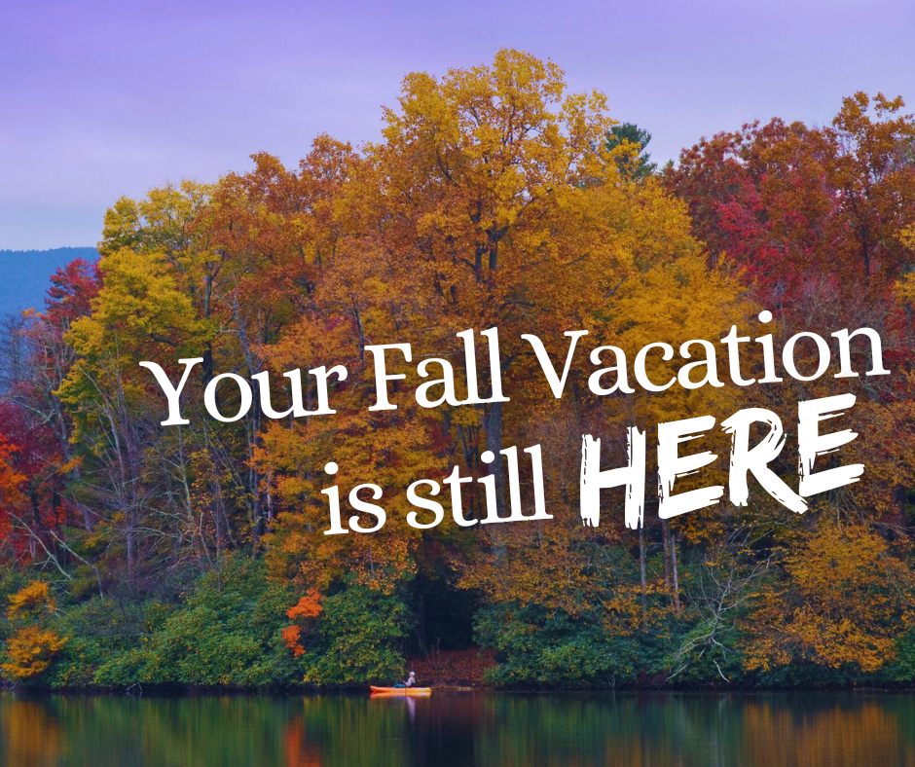 | While some of our region took a heart-breaking hit from Hurricane Helene, many in our mountain region are recovering and ready for you to join us. Consider this an open invitation from [Business/town] to come and enjoy the amazing Fall leaf season in the Smoky Mountains.  #VisitNC #visitnorthcarolina #northcarolinaoutdoors #828isgreat #WNCsmokies #VisitSmokies
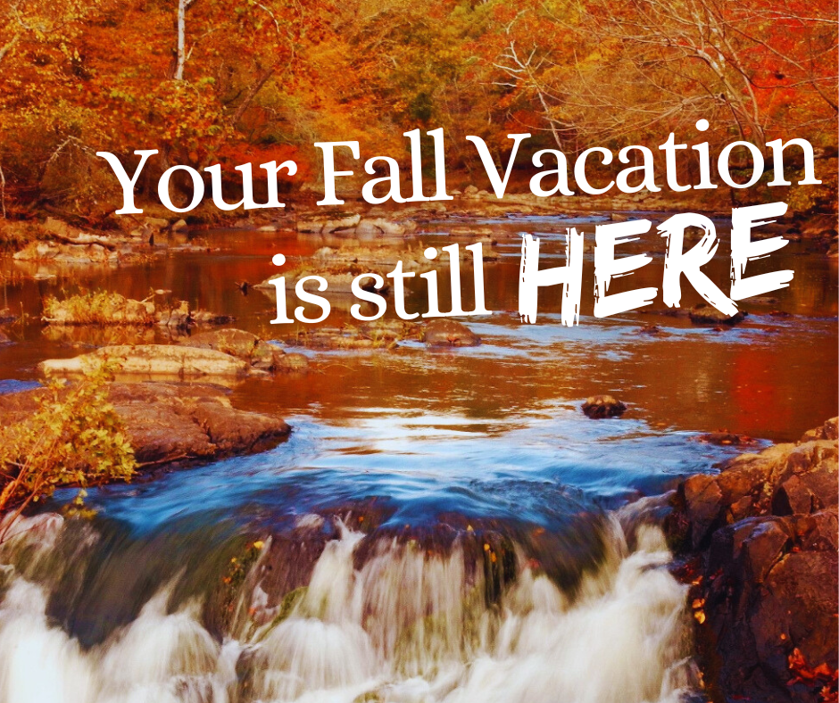 | The Great Smoky Mountains Experience is ready and waiting for you this Fall.  Remember that some surrounding communities are still recovering from Hurricane Helene, so please travel thoughtfully and check with DriveNC.gov for road conditions when passing through impacted areas.  #VisitNC #visitnorthcarolina #northcarolinaoutdoors #828isgreat #WNCsmokies #VisitSmokies
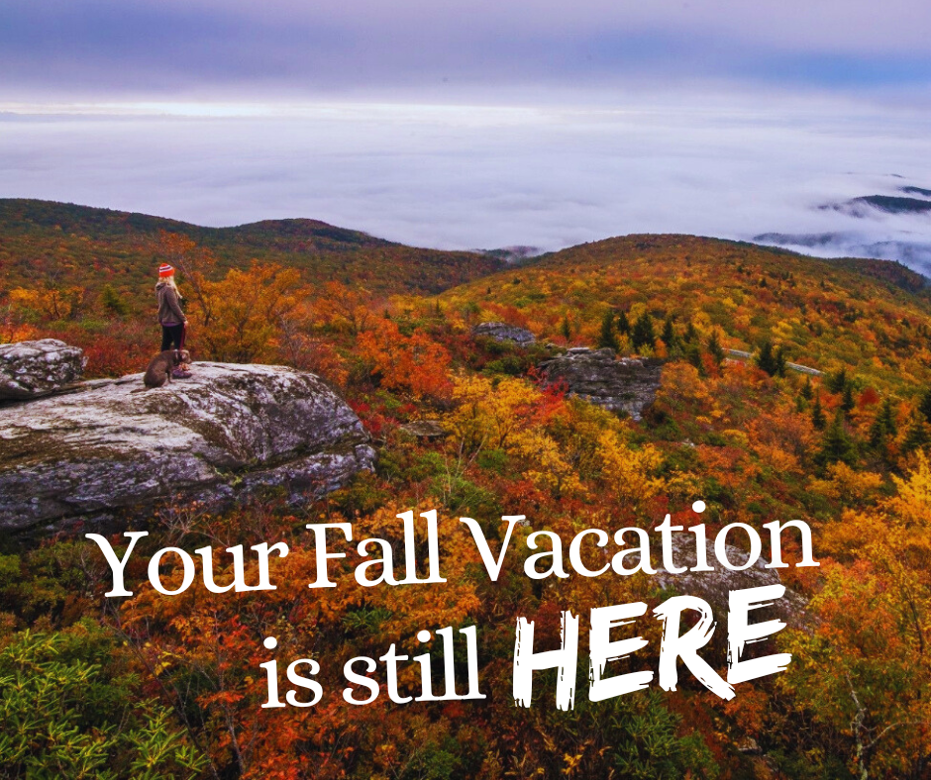 | While some of our region took a heart-breaking hit from Hurricane Helene, many in our mountain region are recovering and ready for you to join us. Consider this an open invitation from [Business/town] to come and enjoy the amazing Fall leaf season in the Smoky Mountains.  #VisitNC #visitnorthcarolina #northcarolinaoutdoors #828isgreat #WNCsmokies #VisitSmokies
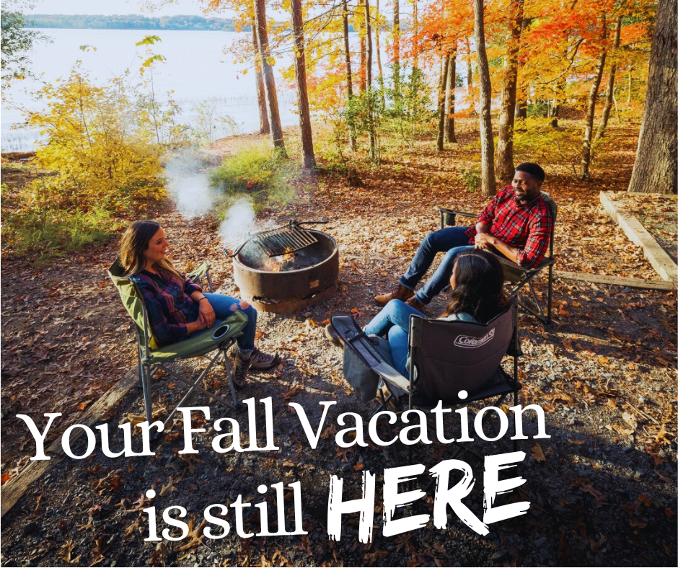 | Our breathtaking views are sparkling as the leaves change colors. And now that the mild temperatures make the Smokies so comfortable for an evening around the fire pit, or in town at business/event, now is the time to plan the perfect end-of-summer getaway.  Please travel thoughtfully and check with DriveNC.gov for road conditions when passing through areas impacted by Hurricane Helene.  #VisitNC #visitnorthcarolina #northcarolinaoutdoors #828isgreat #WNCsmokies #VisitSmokies
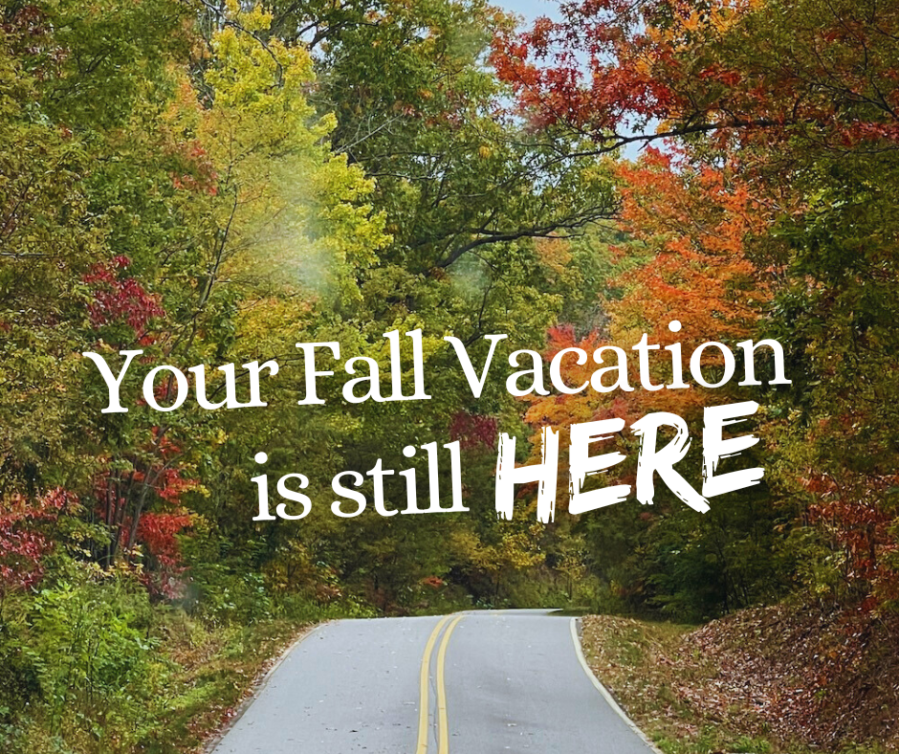 | Our scenic drives are especially stunning as the leaves change colors.  Remember that some surrounding communities are still recovering from Hurricane Helene, so please travel thoughtfully and check with DriveNC.gov for road conditions when passing through impacted areas.  #VisitNC #visitnorthcarolina #northcarolinaoutdoors #828isgreat #WNCsmokies #VisitSmokies

