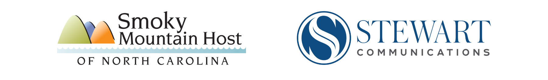

Post-Helene Tourism Recovery
Letter to the Editor Template

Dear Editor,

I’m writing as a [business owner/local tourism representative] in [location].

We want all of your readers to know that our [location] welcomes visitors during this magical time of year in the mountains. The leaves are changing, the weather is cool and crisp, and our roads are open.

More importantly, we need your business. While Hurricane Helene caused a heartbreaking amount of damage to parts of the WNC Smokies community, not all of our counties and towns were damaged. Subsequently, at a time when our towns would be booming with tourists just before our slowest season (winter), many of our businesses are reporting cancellations and reduced sales.

We know people are concerned about the devastation around Asheville and the people still suffering there, and our community is helping every chance we get. What concerns us is the “storm after the storm”. If our regular tourists are worried about visiting, they shouldn’t be. We are open, and we invite you to visit.

That said, we do ask that all our visitors travel informed.

We’re grateful that the travel restrictions have been lifted in Western NC. While virtually every major roadway is open, but for a section of I-40 and I-26, please check with DriveNC.gov to get the latest driving conditions (not all the GPS apps are updated as regularly).

Also, check with your preferred lodging choice. Many of our larger hotels are housing restoration workers. Consider our Bed & Breakfasts, campgrounds and our many vacation rental homes. Again, call ahead to make sure they are available.

Finally, while traveling informed is important, traveling sensitive is critical. Avoid the damaged areas. People are trying to survive and recover, and first responders are attempting to work safely. Sightseers and unnecessary traffic can impede the recovery work. Come and enjoy our mountains, waterfalls, festivals, restaurants, and shops. Explore our hiking and biking trails, and maybe a relaxing lounge chair near a fire pit, but take care for those who need it.

Again, we need and want your business now more than ever. Visit [location] and help us recover, too.

Sincerely,

XXX

# # #

