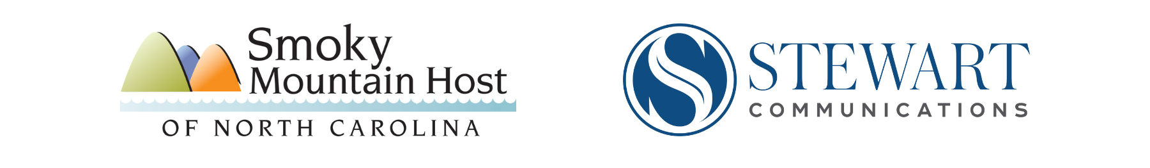

Post-Helene Tourism Recovery
Financial Resources

Through thorough research and inquiry, we have compiled a list of potential funding resources for businesses affected by Hurricane Helene. The list below doesn't contain every source (things change daily), but it might help you get started. Not every resource is for every business, so spend a few minutes reading to learn about each opportunity.

The Economic Development Partnership of NC has a comprehensive list: https://edpnc.com/resources/publications/disaster-recovery-resources/

Community Foundation of WNC: https://cfwnc.org/grants/emergency-and-disaster-response-fund

Mountain Biz Works: https://www.mountainbizworks.org/helene/

FEMA: https://www.fema.gov/disaster/4827

SBA: https://lending.sba.gov/search-disaster/?disaster=NC-20007

IRS: https://www.irs.gov/newsroom/irs-provides-relief-for-helene-various-deadlines-postponed-to-may-1-2025-part-or-all-of-7-states-qualify

Restaurants & Hotels and their employees: https://recovery.ncrla.org/ and also https://southernsmoke.org/

Artists and Crafters: https://cerfplus.org/

The NC Arts Council has many specific resources and grants for artists: NC Arts Disaster Relief Resources – Arts North Carolina (artsnc.org)

