HAYESVILLE SECTION 2019 GUIDE – LATEST
Use this on page 102
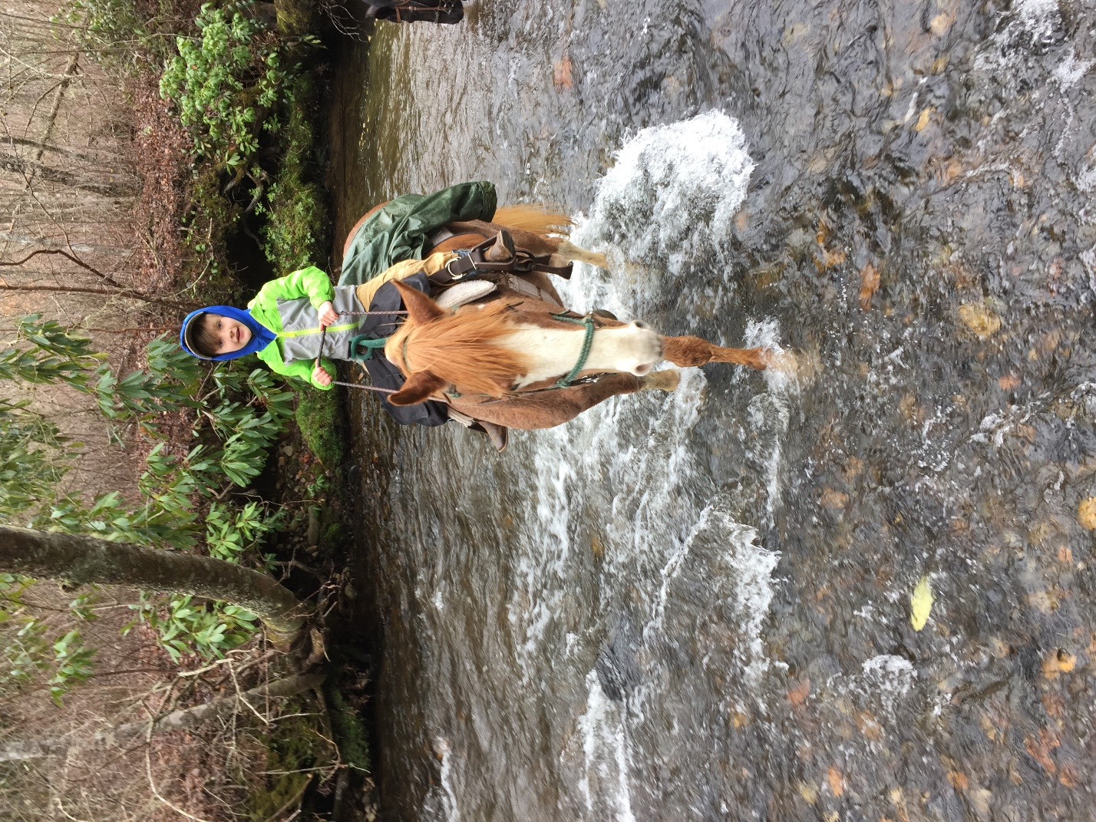
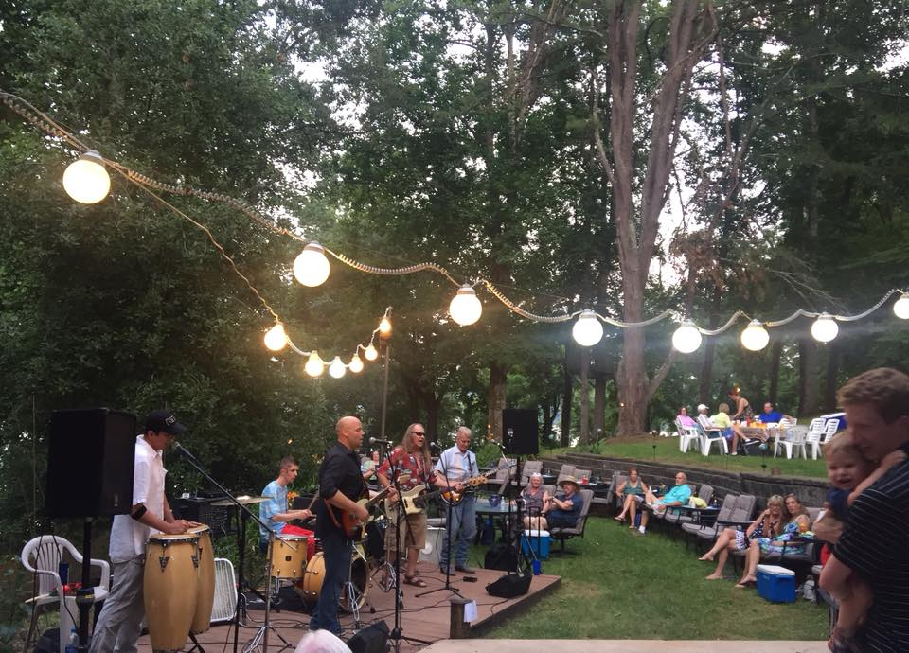
Mention Goldhagen Hot Summer Nights

Add breweries after restaurants to the first paragraph. After Live music, or the Peacock Performing Arts Center for music events, theater. See glassmaking at Goldhagen Studio Gallery.
HAYESVILLE
Page 108: Add Events:
Clay County Courthouse/Beal Center – Restored 1888 courthouse in the square, ​perfect venue for weddings, family gatherings, celebrations of life.
Main Street
Hayesville 28904
828-415-1623
Bealcenter.org
Page 109: The Copper Door – new ad (changed times)
Remove: Sundowner RV Village (I’ll see if I can get a campground)
Page 110: Peacock Perf Arts… Events, children's plays, dance, concerts, shows, entertainment
thepeacocknc.org
Pg. 110: Jackrabbit Mountain Trail add: hiking, biking
Fires Creek Area Trails: add hiking, biking, horse trails
Quannassee Path - Two-mile Cherokee History Trail, downtown, depicting culture of Cherokee people at five historical sites
Clay County Chamber of Commerce: remove 877#
Clay County Travel & Tourism – change
33 Main Street, 828-389-0089
ClayNC.US
Remove Clay Co T&T AD
Pictures below: Use lake chatuge pic from 2016 guide?
Getting pictures
Chunky Gall Stables website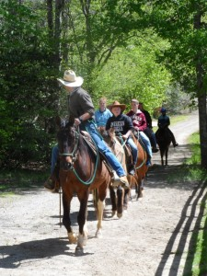

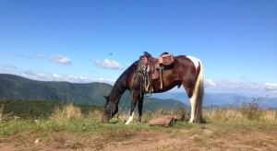
Hinton Center
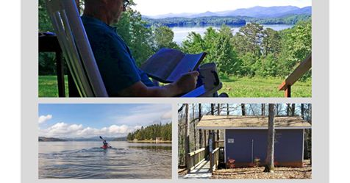
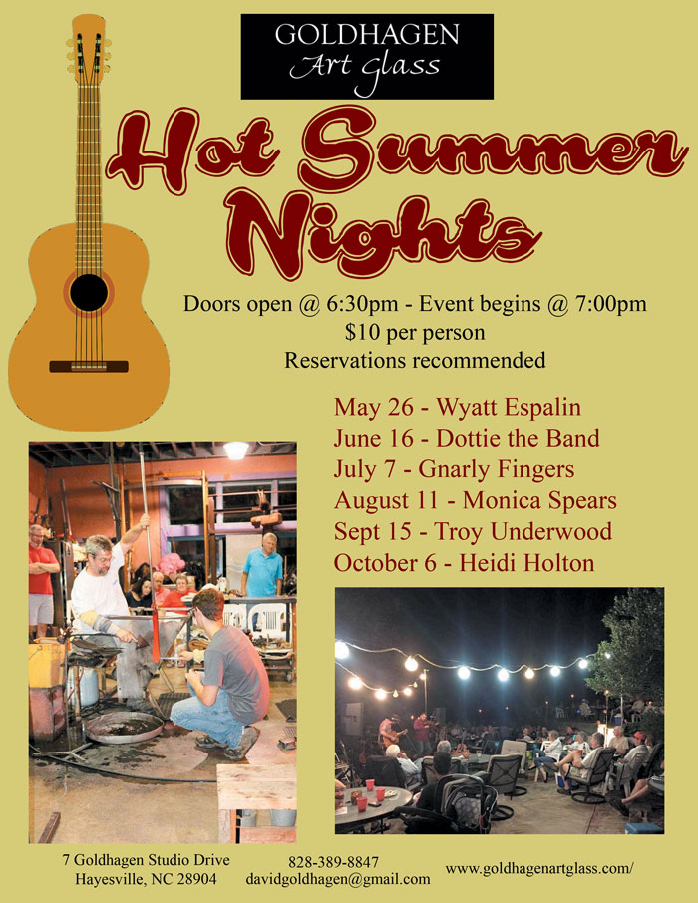
Goldhagen Hot Summer Nights facebook
Timeline Photos
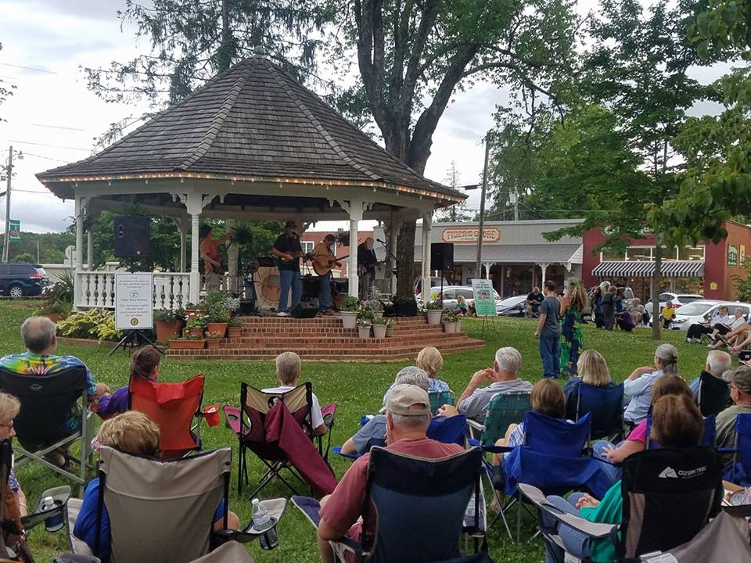
Ncmtnchamber.com

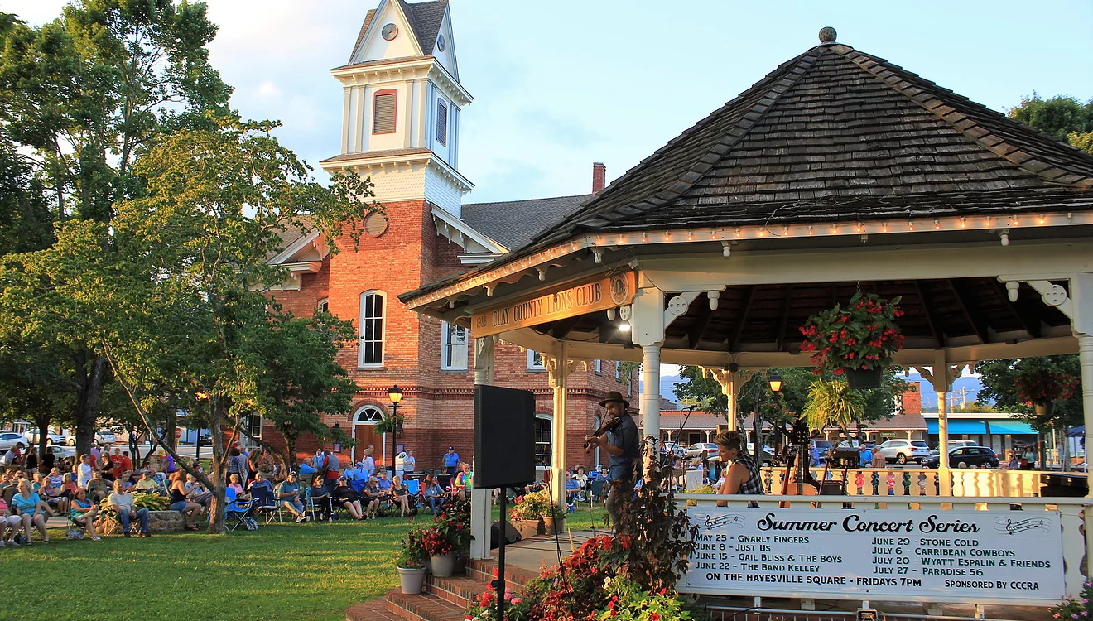
CCCRA website
